15.39: a)
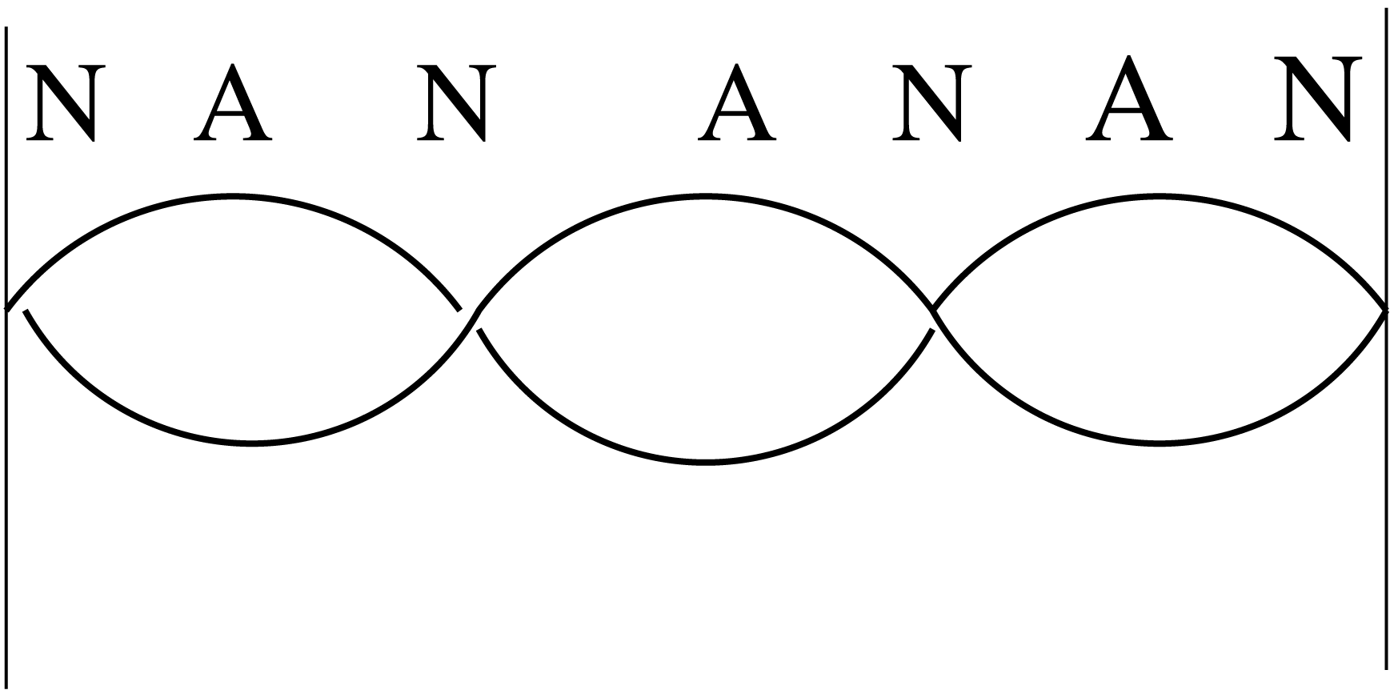

b) Eq. (15.28) gives the general equation for a standing wave on a string:
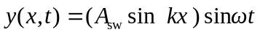

c) The sketch in part (a) shows that 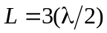

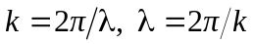

Comparison of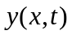given in the problem to Eq.(15.28) gives 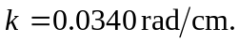

So,

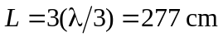

d) 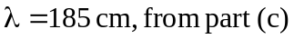

period 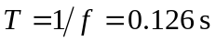

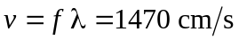

e) 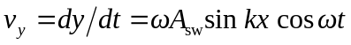

f)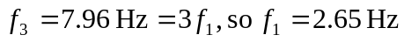 is the fundamental

